COMSAT UNIVERSITY ISLAMABAD

ABBOTTABAD CAMPUS

“Object Oriented Software Engineering”

**Semester Project Proposal**

*“Attendance Management System”*

***Group Members***

|  |  |
| --- | --- |
| Shamsa Rani | FA21-BSE-145 |
| Aqsa Shabbir | FA21-BSE-079 |
| Ahsan Zeb | FA21-BSE-071 |
| Shahzaib | FA21-BSE-034 |

**Submitted to:**

Mukhtiar Zamin

Table of Contents

CHAPTER 1 PROJECT PROPOSAL 2

Introduction 2

Vision and Business Case 3

Use-Case Model 3

Supplementary Specification 4

Glossary 4

Risk List & Risk Management Plan 5

Chapter-2 6

Use Case Distribution Table 6

Use case Diagram. 7

Shahzaib (FA21-BSE-034): 8

Brief level use case 8

Shamsa (FA21-BSE-145) 8

Brief level use case 8

Aqsa (FA21-BSE-079) 10

Brief Level Use case 10

Ahsan (FA21-BSE-071) 10

Brief Level Use cases 10

FULLY DRESSED USE CASES 11

Shahzaib: 11

Shamsa: 13

Fully dressed use case: 13

Prototypes 15

# CHAPTER 1 PROJECT PROPOSAL

## Introduction

* 1. **PROJECT OVERVIEW**

The Attendance Management System is a software developed for daily student attendance in university. It facilitates to access the attendance information of a particular student in a particular class. The information is sorted by the operators, which will be provided by the teacher for a particular class. This system will also help in evaluating attendance eligibility criteria of a student.

**1.2 PROBLEM STATMENT**

Attendance management has always been a challenge for colleges, with traditional methods like manual registers proving to be inefficient and time-consuming. An Attendance Management System can automate the process, making it easier and more accurate. The main aim of proposed system is to maintain attendance record of the students for a university. This will eliminate the need for manual registers and reduce the possibility of proxy attendance.

ATTENDENCE MANAGEMENT SYSTEM (AMS) has four user module to run the system i.e. Admin, Staff, Student and Guardian. Initially the system will be blank, The Administrator has a rights to create standard and classroom for school and same time he has to add staff detail. Administrator generates unique username and password for all staff while adding staff detail. All staff maintain attendance of student, generate reports month wise, date wise. Guardian will be able to view their children’s attendance and Contact with relevant staff members.

* 1. **OBJECTIVES**
* To make it easier and faster for administration to keep track of student’s attendance.
* To maintain a secure and proper attendance report of students.
* To build a connection between guardians and teachers.

## Vision and Business Case

An attendance management system (AMS) is a software solution that educational institutes to efficiently track and manage student attendance, absenteeism, and leave requests. The vision for an AMS is to provide a centralized system for managing student attendance data, reducing manual data entry, and providing real-time visibility into attendance trends and patterns.

The business case for an AMS includes several benefits for institutes, including:

* **Improved Efficiency:** An AMS can significantly reduce the time and effort required to manage attendance data, freeing up administration personnel to focus on more strategic activities.
* **Increased Accuracy:** An automated system can eliminate errors associated with manual data entry, ensuring that attendance data is accurate and up to date.
* **Enhanced Student/Guardian Engagement:** By providing employees with self-service access to their attendance data and staying in touch with guardians of students, an AMS can increase transparency and trust between students, guardians and administration.
* **Cost Savings:** An AMS can help organizations reduce the cost of manual attendance tracking, such as paper-based timesheets and manual data entry, as well as minimize the risk of costly compliance violations.

## Use-Case Model

* **Student Attendance Tracking:** This use case involves students using the system to mark their attendance, either through a web-based interface or a mobile application. The system records the attendance data and provides real-time reporting to faculty and administration.
* **Attendance Analytics:** This use case involves faculty and administration using the system to analyze attendance data and identify trends, such as low attendance rates or frequent absences. The system may also provide insights into student engagement and academic performance.
* **Leave Management:** This use case involves students using the system to request time off for reasons such as illness, family emergencies, or academic competitions. The system routes the requests to the appropriate authority for approval and records the time off in the attendance database.
* **Compliance Reporting:** This use case involves the system generating reports that demonstrate compliance with regulations, such as the University Grants Commission (UGC) guidelines and accreditation requirements.
* **Notifications and Alerts:** This use case involves the system sending notifications and alerts to students and faculty regarding attendance requirements, upcoming events, and important deadlines.
* **Security and Access Control:** This use case involves the system providing secure access to attendance data, ensuring that only authorized personnel can view or modify the data.

## Supplementary Specification

Here are some possible supplementary specifications for Attendance Management System:

* **User Roles:** The system should provide different user roles with varying levels of access and permission. For example, students may only have permission to mark their attendance and view their records, Guardians would be able to look up to their children’s attendance report while faculty and administration may have permission to view and modify attendance records for all students.
* **Integration with Student Information System (SIS):** The system should integrate with the university's SIS to access student information, such as course enrollment and class schedules, to ensure accurate tracking of attendance.
* **Attendance Policies:** The system should allow the university to define and enforce attendance policies, such as minimum attendance requirements, late arrival policies, and penalties for non-compliance.
* **Attendance Reports:** The system should provide a range of reports to help faculty and administration analyze attendance data and identify trends, such as daily/weekly/monthly attendance reports, absenteeism reports, and class-wise attendance reports.
* **Mobile Application:** The system should have a mobile application that allows students to mark their attendance, view their records, and request time off from their mobile devices.
* **Web Based Interface:** The system should have a website that allow students, guardian and staff to view attendance records, and perform other relevant actions.
* **Notifications and Alerts:** The system should send notifications and alerts to students and faculty regarding attendance requirements, upcoming events, and important deadlines.
* **Data Security:** The system should ensure that attendance data is secure, with access restricted to authorized personnel only. The system should also comply with data privacy laws and regulations.
* **Technical Requirements:** The system should specify technical requirements such as hardware, software, and network infrastructure, necessary to run the system efficiently and effectively.
* **Support and Maintenance:** The system should provide ongoing support and maintenance to ensure that the system is up-to-date, and any issues or bugs are addressed promptly.

## Glossary

* **AMS:** Attendance Management System.
* **SIS:** Student Information System.

## Risk List & Risk Management Plan

Here are some possible risks that may be associated with Attendance Management System, along with a risk management plan to address each risk:

* **User Error:** The risk that teachers may make mistakes when using the system, such as marking incorrect attendance or entering incorrect data. The risk management plan includes user training and education, user-friendly interfaces, and automated data validation to minimize this risk.
* **Developer’s Negligence:**

When a team of developers work on a project, they may design different style or type of models for a single entity. This leads to confusion for both the user and developers. The risk management plan will keenly look into such matters and correct them right on spot to avoid any future errors or faults in the system.

* **Non-compliance:** The risk that the system may not comply with legal or regulatory requirements, such as data privacy laws or accreditation requirements. The risk management plan includes regular compliance audits and reviews and updating the system to meet any new legal or regulatory requirements.
* **Poor User Adoption:** The risk that students or faculty may not fully adopt the system, resulting in incomplete or inaccurate attendance data. The risk management plan may include user training and education, and ongoing communication and support to ensure that users understand the benefits of the system and how to use it effectively.
* **4. Negligence**: When data is stored in computers or laptops, it has become so natural that people lose the information when files are accidentally deleted or even it could fall into the wrong hands. Ensure a proper backup strategy to keep your data on important devices and run them smoothly without hassles.
* **Unsafe data:** If adequate safety precautions are not taken when files and documents are shared in website, smartphones and tablets via internet networks, the information contained on them might gain access to the devices and get exposed to risks. We can make use of cloud deployments to manage the education system better and better.

# Chapter-2

## Use Case Distribution Table

|  |  |  |
| --- | --- | --- |
| **Sr#** | **Group Members** | **Assigned use cases** |
| 1 | FA21-BSE-034 | 1. Mark Attendance 2. Search Student 3. Check Attendance 4. Check Class |
| 2 | FA21-BSE-145 | 1. View Attendance 2. Communicate with Teacher 3. Update Information |
| 3 | FA21-BSE-071 | 1. Edit Profile 2. Login 3. Notify |
| 4 | FA21-BSE-079 | 1. Logout 2. Generate Discipline Report 3. Manage Settings |

## Use case Diagram.

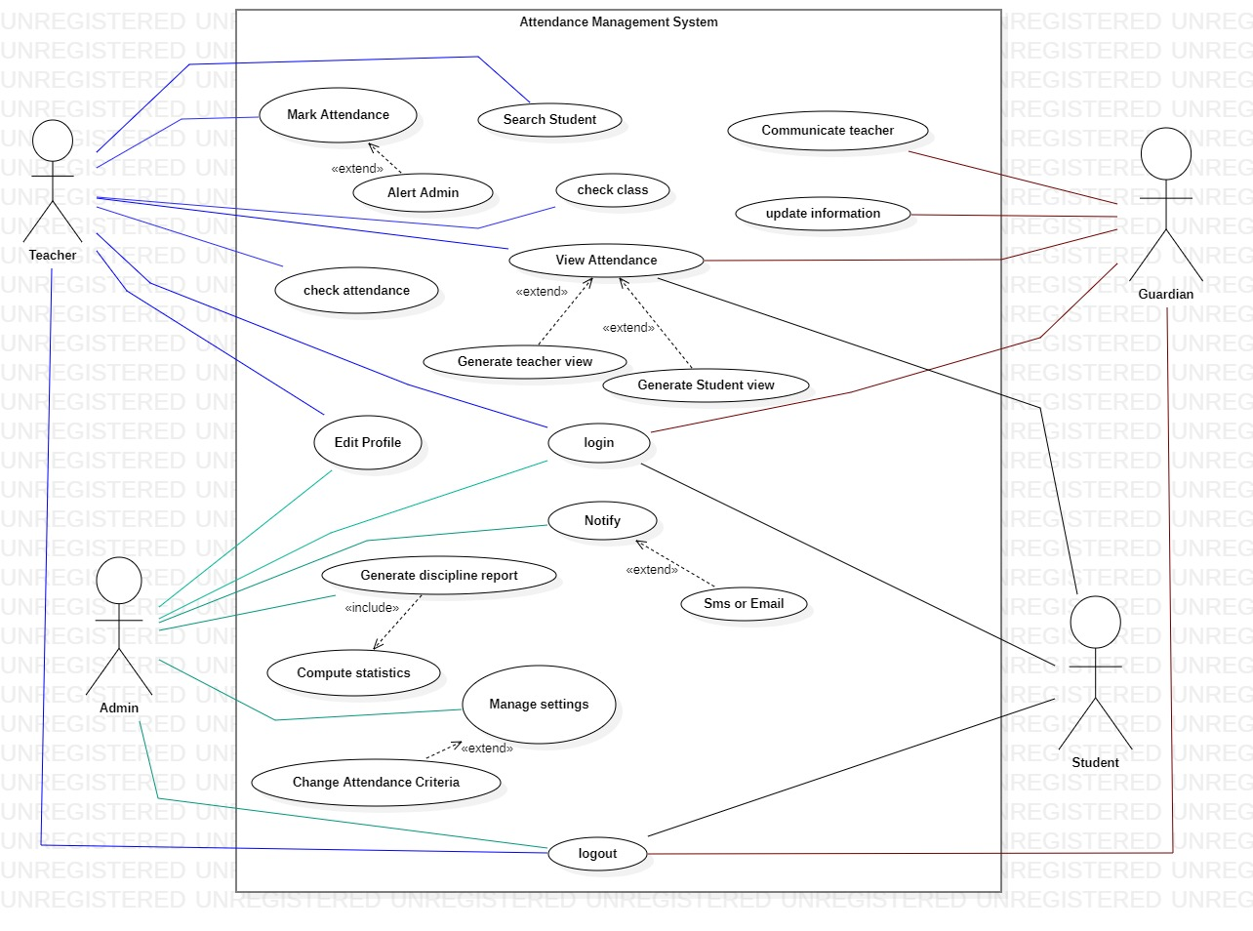

## Shahzaib (FA21-BSE-034):

### Brief level use case

1. **Mark attendance**

This use case starts when teacher enters the class and needs to mark attendance of students. System will display login screen where teacher enters their credentials such as name and password to login to system. Upon successfully login system enables teacher to choose particular class and section of which the attendance is to be marked. After selecting the particular class teacher will mark present, if student attends class or absent otherwise. System also allow teacher to change the marked attendance. In case of late appearance of student in class it will totally depends upon teacher whether he/she wants to mark absent or present.

1. **Search student**

This use case will starts when teacher or admin wants to search the attendance record about a particular student from the attendance management system. System allows the teacher/admin to enter name or registration no. of particular student and then system retrieve and display the relevant information. If user had entered wrong name or reg no system will display error message and prompt user to enter the correct information.

1. **Check attendance**

This use case starts when teacher wants to check attendance of some particular class from attendance management system. System enables the user to select particular class whom attendance id to be viewed. After selecting class attendance management system also allows the user to select particular section of that class to check attendance of that class.

1. **Check class**

This use case starts when teacher enters the class room and needs to mark attendance of that class. First of all teacher will login to AMS (attendance management system ) by entering their credentials such as name and password. After logging in teacher has to check the class of which he/she have to mark attendance. System will allow teacher to enter name of that particular class and also select their sub section to mark attendance.

## Shamsa (FA21-BSE-145)

### Brief level use case

1. **View attendance**

The user enters their specific login information, usually their ID and password, to access the attendance management system. System will verify the users credentials if the credentials are valid system will successfully login and display the dashboard of AMS according to user’s role (admin, teacher, guardian and student).

**Student view:**

The system shows the student's attendance history for each class period, indicating whether they were Present or absent. The student has the option to see their attendance records for a single class and even see in which lecture they were absent.

**Guardian view:**

The system shows the attendance records of their child for all classes, indicating whether they were Present or absent. The guardian can see the attendance data for their child for a given class period or for month or semester. In addition, the guardian has access to information about attendance trends and patterns for their child, such as average attendance rates and the number of absences and late arrivals. The system may send the guardian notifications or alerts if their child’s attendance is below then 80%.

**Teacher & Admin view:**

The system displays the attendance records of all students in their classes, indicating whether they were Present or absent. The admin or teacher can view the attendance data for specific class session or for a particular class period or for month or semester.

The administrator can also create attendance reports for the institution that display attendance patterns and trends, such as the average attendance rate of absences in  various departments and classes. The system's access permissions, user accounts, settings, and parameters can all be controlled by the administrator.

1. **Communicate with teacher**

* This use case will begins when the student has a history of frequent absenteeism, the guardian might be concerned or wonder about it. By sending messages through the system, the guardian can contact their Childs teacher about attendance concerns. The parent can read the teachers' responses in the system and, if necessary, carry on the conversation.
* The teacher can reply to the parent's messages through the system, offering explanations or suggestions for how to fix the attendance problems.
* The administrator may see the communications between the teachers and parents, ensuring that they are acceptable and productive.

1. **Update information**

This use case will begins when user login to AMS by entering their credentials.

* If guardian wants to update their information system enables the guardian to modify personal data, including contact information, emergency contacts, etc. The guardian may also modify their child’s personal data, including address, phone number, and medical history. The system saves the changed data, making it accessible to the administration and the student's teacher.
* The system allows the administrator to access and update the personal information of guardians and their wards. The administrator can add or remove guardians, as well as update their contact details or emergency contact information. The administrator can also update the personal information of students, such as address, phone number, medical information, etc. The updated information is saved in the system and is available for access by the guardians and the student's teacher.

## Aqsa (FA21-BSE-079)

### Brief Level Use case

1. **Edit profiles.**

This use case begins when the user enters their specific login information, usually their ID and password, to access the attendance management system. When user wants to edit their profile they select the edit profile option system will display the users profile information, including name contact details or any other relevant information. The user can change their name, email, phone number, and address on their profile. The user has the option of updating their password or adding a profile picture. The user can save the modified profile information after making changes.

1. **Login**

* The user opens the attendance management system on their device and navigates to the login bar. Then user enters their credentials such as name and password. System verifies the credentials and grant access to appropriate features and information. The system displays an error notice and asks the user to try again or change their password if their login credentials are incorrect.
* The system will send an email with instructions on how to reset the password if the user requests a password reset because they have forgotten their password.

1. **Notify**

This use case will begin when attendance of student is below than 80% i.e the criteria set by institution. Teacher will notify guardian of student whose attendance is below 80% if actions are not made by guardian then teacher will alert them that particular student cannot appears in exam if their attendance is below 80%.

## Ahsan (FA21-BSE-071)

### Brief Level Use cases

1. **Logout**

This use case begins when user is currently logged in to the AMS and wishes to logout from the attendance management system. User navigates to the logout button and clicks it. AMS detects that user initiate logout process then system logged the user out of system and redirects the user to login page and system clears the user’s session.

1. **Generate discipline report**

The administrator accesses the attendance management system by entering their credentials such as name and password. The administrator visits the page where the discipline report is generated. The administrator decides on the report's date range and any additional important filters, including grade level based on the chosen criteria, the system generates the discipline report and presents it on the screen. The report is shown on the screen by the system, and the administrator has the option to download or print it.

1. **Manage settings**

The administrator accesses the attendance management system by entering their credentials such as name and password. After successfully logging in to the AMS system allows admin to navigate to settings page. System stores various settings that can be customized by admin so system allows admin to access and change these settings according to needs. The administrator can control a variety of system preferences such as

* Languages preferences
* Time and date format
* Options for notifications
* security parameters
* user roles and permission
* change attendance criteria

Admin can customized these settings according to need of organization and then save it.

# FULLY DRESSED USE CASES

## Shahzaib:

1. **mark attendance**

* **Scope:** University attendance system
* **Level :** User goal
* **Primary actor:** Teacher
* **Stakeholders** and interests
* **Teacher**

Teacher is responsible of marking students of selected class to ensure accuracy of attendance record.

* **Student**

Attends class and keeping track of their attendance percentage

* **Guardian**

Monitors their child’s academic progress and ensure their regular attendance percentage

* **Pre-conditions**

The mechanism for tracking attendance is accessible by the teacher. The method for tracking attendance is working properly.

* **Post conditions**

The attendance management system has been updated with the attendance marks. Updates have been made to the student's attendance record.

* **Main success scenario**
* User logs in to the AMS with their authorized credentials.
* User select particular class for whom they want to mark attendance for.
* AMS retrieve the list of student enrolled in that particular class. A list of students enrolled in the given class and date is shown by the system, and any modifications made by the teacher are updated in real-time.
* User then mark attendance of each student present or absent manually.
* AMS update attendance in real time.
* **Extensions**
* The teacher won't be able to record attendance manually if the attendance management system is down or has technical issues.
* The teacher won't be able to manually mark attendance if they don't have permission to have access to the attendance management system.
* The teacher can use a different device to access the system or get help from the system administrator if they run into technical issues when recording attendance.
* The database will be updated to reflect the changes if a student's attendance status changes after it has been noted, and the teacher can update the attendance status in the system.
* The teacher can visit the system at a later time and register attendance later if they neglect to mark attendance for a certain time or date.
* **Special requirements**
* Text must be visible from 1 meter
* When user enters its credentials verification response is within 20 sec 90% of the time.
* The interface of the system should be straightforward and easy to grasp.
* Marking attendance of students should be easy and fast.
* As required by the system, the typography is treated with extreme strictness.
* **Technology and data variation list**

**Internet access:**

The university attendance system should be able to accommodate fluctuations in internet access, such as slow connectivity, for both teachers and students.

**Various data:**

Privacy options: To prevent the release of student attendance records to unauthorized parties or entities, the university attendance system should have privacy settings.

**Course schedules**:

Variations in course schedules, such as changed class times or cancellations due to any situation, should be supported by the university attendance system.

**Student information:**

The university attendance system ought to be able to accommodate changes.

* **Open issues**

**• Attendance rules and policies:**

At the university, different departments and courses may have different attendance rules and practices. To account for these changes while maintaining consistency in data collecting and reporting, the attendance system should be designed.

**• Data accuracy:**

It's critical to make sure that the university attendance system is collecting correct and current attendance information. For students inaccurate attendance records can have detrimental effects, such as hurting grades or causing administrative problems. To ensure correctness, the system should undergo routine audits and updates.

**• User interface design:**

The university attendance system's user interface, including the "Mark Attendance" capability, should be simple and easy to use.

## Shamsa:

## Fully dressed use case:

* **Use case:** view attendance.
* **Scope:** University attendance system
* **Level** : User goal
* **Primary actor:** student, guardian
* **Stakeholders and interests**

• **Teacher:** Needs a quick and easy way to view student attendance records for a specific course and spot attendance patterns and trends.

• **Students:** want information about their attendance status and progress as well as reliable and easily available attendance records.

**• Administration:** Wants to make sure that attendance rules and policies are followed, as well as to maintain precise attendance records for auditing purposes.

* **Preconditions**

To access the system, actors must have valid login credentials. There must have been an earlier creation and storage of attendance data in the system.

* **Post condition**

To keep track of the actor's actions, the system refreshes the access log. The system is still in a position where other actors can access attendance information.

* **Main success scenario**
* Actor enters their login information into the attendance tracking system.
* Actor chooses from the system menu's "View Attendance" option.
* A list of the students connected to the actor's account is shown by the system.
* To view a student's attendance history, the actor chooses a name from the list.
* The actor sees the attendance history that the system has pulled up for the chosen student.
* Depending on the options the system offers, the actor can examine the student's attendance record for a specific day, week, month, or semester.
* Additionally, the actor can see information on any excused absences or tardiness for the chosen time frame.
* If the actor is a teacher, they can also, if necessary, edit the selected student's attendance record.
* The actor may log out of the system once they viewed attendance.
* **Extension**
* The system will display an error warning and direct the user to get in touch with the system administrator if the actor's account is empty of any students.
* The system will prompt the actor to try again with a valid student if they choose a student that doesn't already exist in the database.
* The actor might ask the system admin for help if they run into any technical difficulties when viewing attendance records.

# A picture containing graphical user interface Description automatically generatedPrototypes

